Include a photo if you wish.
Enter in your own data and photo of yourself or one related to your talk. Save it with the title of your talk & then email and put Speakers Bureau in the Subject Line to wimgaorg@gmail.com

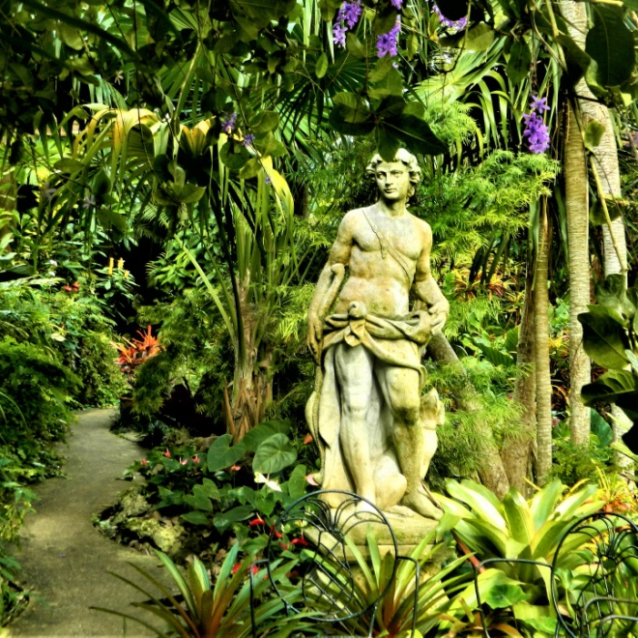
Your Name: Don Brill
Your Email: donal.brill@gmail.com
Your Street Address: 706 Lincoln St.
City: Neenah
County: Winnebago
State: WI
Phone Number: 920-470-2067
Distance Willing to Travel: WI
Bold the one category that best describes your talk:
- Fruits, Vegetables, Herbs
- Trees & Shrubs
- Perennials
- Garden Design
- Natives or Pollinators
- Garden Pests
- Other

Talk Description & Bio
- Enter Brief Talk Description Here
Tropical Gardens of Barbados & Miami can help you add a tropical look to your garden. These are the best areas in US and W Indies to see great tropical gardens including a sinkhole garden. Learn how to great gardens from photos.
Brief Bio Here in this space including Master Gardener status )
I am a Master Gardener, at retirement I took 2 years of horticulture classes at Fox Valley Technical College including a year each of design and maintenance. I have designed gardens, with features clients chose.

3/1/2018 emt

