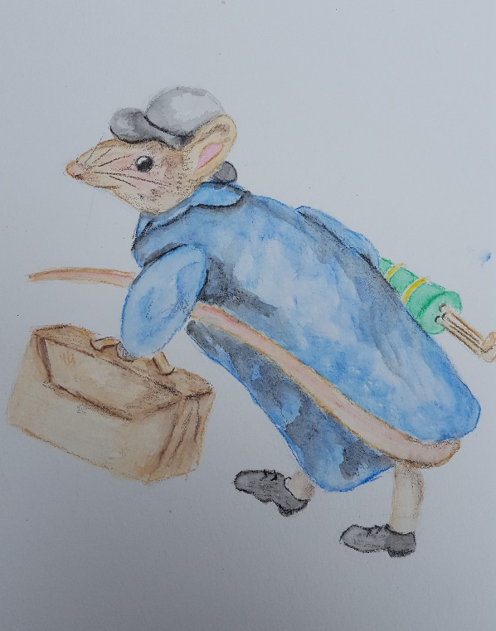
Enter in your own data and photo of yourself or one related to your talk. Save it with the title of your talk & then email and put Speakers Bureau in the Subject Line to wimgaorg@gmail.com

Your Name: Mary Jo Fleming

Your Email: bingnjo@charter.net
Your Street Address: 18790 54th Ave.
City: Chippewa Falls
County: Chippewa
State: Wisconsin
Phone Number: 715-723-0822
Distance Willing to Travel: 90 miles
Bold the one category that best describes your talk:
- Fruits, Vegetables, Herbs
- Trees & Shrubs
- Perennials
- Garden Design
- Natives or Pollinators
- Garden Pests
- Other

Talk Title: A Kinder, Friendlier Garden

Talk Description & Bio
TALK: As gardeners include more natives in the landscape and plant garden plots for birds and pollinators, they are also creating habitat for small mammals. Who are these small critters and what do they contribute to a balanced, sustainable property?

BIO: As a Chippewa Valley Master Gardener Volunteer and retired teacher, I’ve used my background in biology and my interest in native, sustainable gardening to make landscapes more diverse and a lot more fun.

3/1/2018 emt

