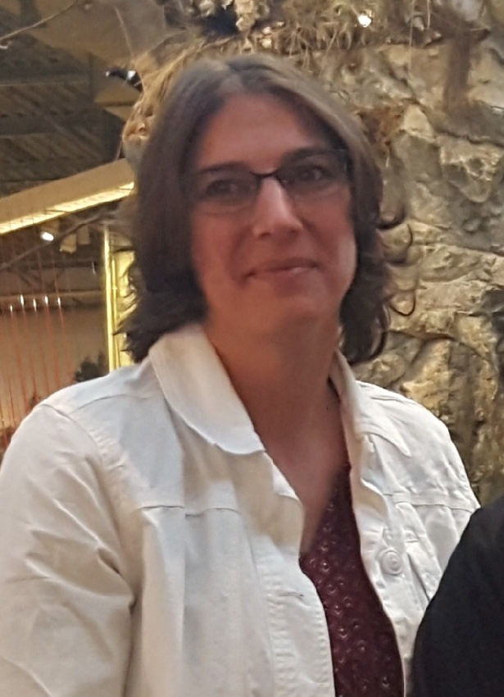
Enter in your own data and photo of yourself or one related to your talk. Save it with the title of your talk & then email and put Speakers Bureau in the Subject Line towimgaorg@gmail.com

Your Name: Dora Wood
Your Email: homeoasisfarm@gmail.com
Your Street Address: 11293 County Highway X
City: Chippewa Falls
County: Chippewa
State: WI
Phone Number: 715-828-3856
Distance Willing to Travel: most anywhere

Bold the one category that best describes your talk:
- Fruits, Vegetables, Herbs
- Trees & Shrubs
- Perennials
- Garden Design
- Natives or Pollinators
- Garden Pests
- Other

Talk Title: Chickens 101

Talk Description & Bio
Brief Talk Description -
Are you interested in having chickens but have some questions? This presentation is designed to set you up for success. We’ll cover terms, classifications, breeds, housing, care and more to help you determine “if” and “which ones” are best for you! I have been raising chickens (egg and meat) for over 20 years and enjoy all things chicken. I love to share my successes and failures, to hopefully keep you from repeating my mistakes so you can try a few of your own.

Brief Bio Here
Dora Wood resides just west of Chippewa Falls along the beautiful Chippewa River on Home Oasis Farm which uses sustainable, organic farming practices along with solar power. She homestead farms along with her husband, youngest daughter, cat, dogs, free range chickens, Belted Galloway beef cattle and often the grandkids. She enjoys gardening – growing numerous fruit trees, grapes, kiwi, mushrooms, various berries, a vegetable garden and some flower gardens, too - which is in part what lead her to become a Chippewa Valley Master Gardener.

3/1/2018 emt

