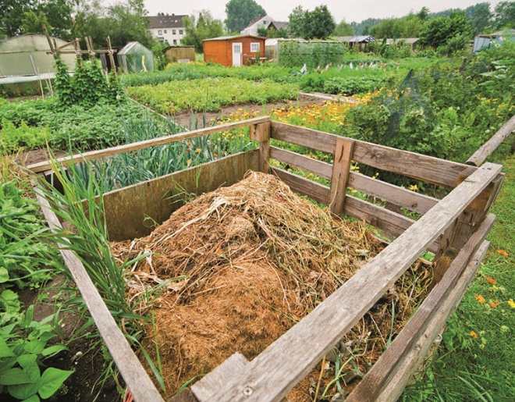
Enter in your own data and photo of yourself or one related to your talk. Save it with the title of your talk & then email and put Speakers Bureau in the Subject Line to wimgaorg@gmail.com

Include a photo if you wish.

Your Name: Becky Gutzman
Your Email: buckhill@centurylink.net
Your Street Address: W3616 Old B Rd
City: Rio
County: Columbia
State: WI
Phone Number: 920-382-4511
Distance Willing to Travel: negotiable
Bold the one category that best describes your talk:
- Fruits, Vegetables, Herbs
- Trees & Shrubs
- Perennials
- Garden Design
- Natives or Pollinators
- Garden Pests
- Other - composting

Talk Title: Let it Rot!

Talk Description & Bio
- Enter Brief Talk Description Here
- Composting is a great way to put the old adage “waste not, want not” into action. Learn how to turn your garden and kitchen waste into black “gold” that will make your garden better than ever.
- Brief Bio Here (Enter your personal Bio in this space including Master Gardener status )
Becky is a life-long gardener and recycler. She enjoys finding new uses for old things, from bed frames to kitchen scraps. She is a Master Composter as well as a Master Gardener Volunteer.

3/1/2018 emt

